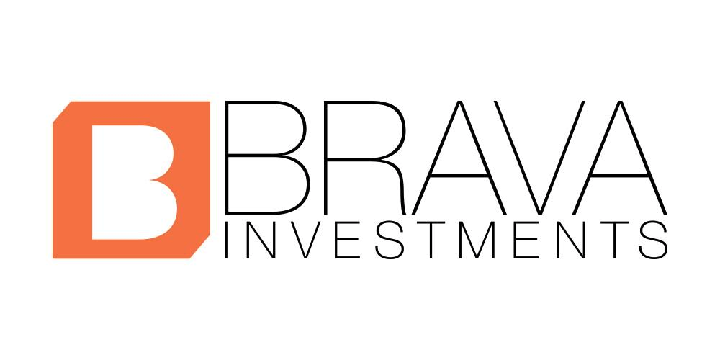

MEDIA RELEASE FORM

For good and valuable consideration, receipt and sufficiency of which is hereby acknowledged, I, ___________________________(your name) hereby grant to BRAVA Investments & Civic Nation, and its subsidiaries, affiliates, successors and assigns, and to other such persons as BRAVA Investments & Civic Nation may designate time to time, the absolute right and permission to use my likeness, voice, name, photographs, film, video and/or images (“Persona”) taken at events sponsored, hosted or otherwise related to BRAVA Investments & Civic Nation, including but not limited to symposia, convenings, town halls and panel discussions, for a period of five years beginning on _____________________ (today’s date) (“Term”), in whole or in part, or distorted in character or form, either alone or accompanied by other material, throughout the world, in perpetuity and royalty-free, for use in any and all media, including but not limited to advertising, promotion, inclusion on BRAVA Investments & Civic Nation’ website, documentary projects, promotional products and merchandise, television broadcast, news coverage, entertainment and current affairs programming, Internet broadcast, podcasts, streaming video, and any electronic media format now known or invented in the future (the “Materials”).
I waive all rights to compensation for use of my Persona. I understand that BRAVA Investments & Civic Nation shall have complete ownership over the Materials and own all right, title and interest, including without limitation all copyrights, trademark rights and property rights, in and to the Materials and hereby waive on behalf all rights to inspect and approve the Materials, its use or such written or spoken copy as may be used in connection therewith.
I agree that I will not hold BRAVA Investments & Civic Nation or anyone who receives permission from BRAVA Investments & Civic Nation, responsible for any liability resulting from the use of my Persona in accordance with the terms hereof, including but not limited to any claims for defamation or what might be deemed to constitute misrepresentation of me, my character or my person due to distortion, optical illusion or faulty reproduction which may occur in the finished product.

I hereby warrant that I am over the age of eighteen (18) and have full authority to execute this Release, which I have read, understood and approved prior to its execution. I hereby agree that I shall be bound to this Release.

Signature Date
Print Name Telephone
Address

